EXPERIMENT- 31
Morphological Operations using Opening Technique
Aim
To write a Python code to perform Morphological Opening operation on an image using OpenCV for removing small noises from the image.
Code
from google.colab import files
uploaded=files.upload()
import cv2
import numpy as np
from matplotlib import pyplot as plt
image_path=list(uploaded.keys())[0]
image=cv2.imread(image_path,cv2.IMREAD_GRAYSCALE)
if image is None:
print("Error: Image not found")
else:
kernel=np.ones((5,5),np.uint8)
opening_result=cv2.morphologyEx(image,cv2.MORPH_OPEN,kernel)
plt.figure(figsize=(10,5))
plt.subplot(1,2,1)
plt.title("Original Image")
plt.imshow(image,cmap='gray')
plt.axis('off')
plt.subplot(1,2,2)
plt.title("Opening Result")
plt.imshow(opening_result,cmap='gray')
plt.axis('off')
plt.show()

Input & Output Image
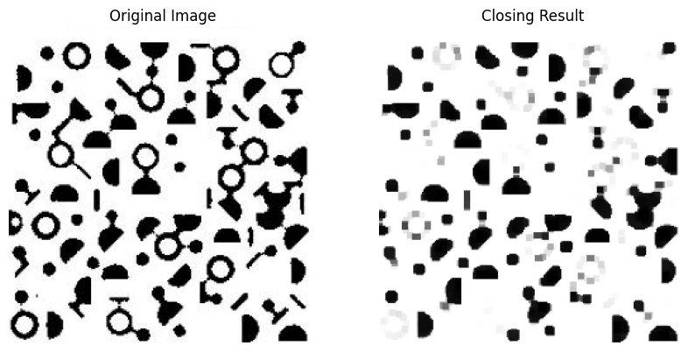
Result
Thus, the morphological opening operation was successfully performed using OpenCV.

